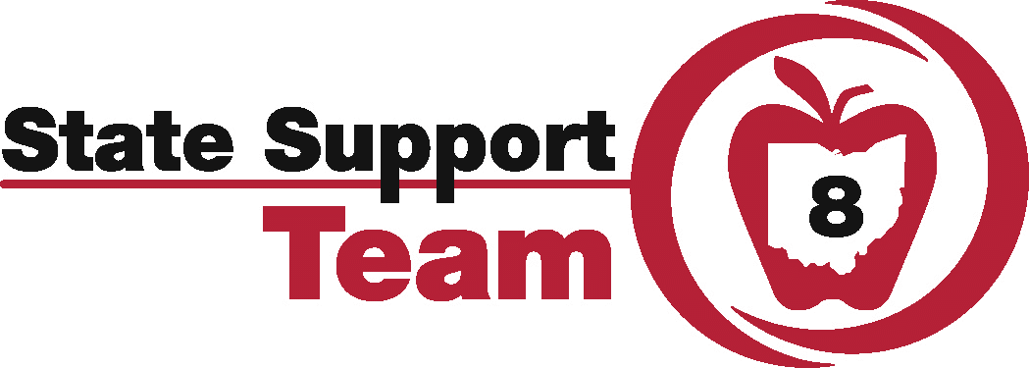

Leading and Implementing Co-Plan and Co-Serve Model Series
Presented by: Tracy Mail (SST8), Dee Dee Howes (SST8), and Matt Young (Summit ESC)
Date: February 27, 28 and March 20, 2019
Time: 9:00 am – 3:00 pm (lunch on your own)
Location: Summit ESC
Audience: District/building administrator(s), instructional coach(es), lead co-teaching teams
Description:
- The primary outcome of this series is to build capacity at the leadership and lead-teacher team levels to implement an effective, sustainable co-plan/co-serve model as part of the LRE continuum of service delivery models.
- Sessions will include consideration of Universal Design for Learning Principles
- Teams will learn, through both the administrative and teacher lenses, how to co-plan, co-instruct, and co-assess considering 8 Components of Co-teaching (what does it look like and sound like when implemented effectively)
- Possible follow-up with districts as determined through a collaboratively created action plan as a result of this training series.
The team will determine ways to measure the effectiveness of 1) the co-teaching teams 2) student progress/achievement attributable to this service delivery model, and 3) the effectiveness of leadership laying the foundation and supporting co-teaching efforts at a building/district level.
As a result of this Series, a SST8 Regional Network of districts/buildings will be created to continue problem-solving, share effective practices, build a regional bank of exemplary team/administrative practices for cross-region collaboration, expand service delivery discussions beyond co-plan/co-serve (LRE Continuum), and support the co-plan/co-serve model after the series ends.
A team application will encourage a district systemic approach for determining series attendees, but individual buildings will be considered. Requires administrator attendance that is in a position to implement evidence based organizational practices to build a successful co-plan/co-serve effort. Also, select lead-teacher co-teaching teams and instructional coaches are encouraged to attend to contribute to the plan to bring the co-plan/co-serve model to full, effective implementation
Please register with team application through Maureen Cacioppo at maureenc@sst8.org or (330) 929-6634 ext. 511219. Questions? Contact Tracy Mail at tracym@sst8.org or Dee Dee Howes at DeeDeeH@sst8.org.
State Support Team Region 8 & Summit Educational Service Center
420 Washington Ave. - Cuyahoga Falls, OH 44221
Sst8.org
(330) 929-6634

