PBIS: Tier II

Presenters: Presenters will include consultants from Region 8 State Support Team

Description:
Some students will respond to the Tier I level of support but will still exhibit some specific difficulties. These students may be demonstrating academic and/or behavioral deficits that will require more intensive supports. Tier II interventions can be effective in working with students at-risk for academic and/or behavioral concerns.
This training will expose participants to Tier II small group interventions. These are strategies and procedures put into place to support a group of students who display similar needs or deficits as identified through the data. The strategies that will be discussed include Check In Check Out (CICO), Social and Academic Instructional Groups, and Check and Connect. There will be a particular focus on CICO, with time provided for teams to begin planning this intervention.

Participants will:
- Use data to determine your building’s readiness for Tier II development
- Identify key features of Tier II
- Learn how Tier II behavioral supports fit within a PBIS framework
- Begin to create a system of Tier II interventions

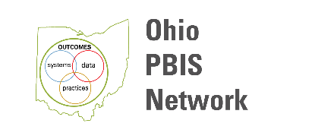
DATE/TIME:  October 28, 2020 OR  February 24, 2021  Registration begins at 8:30 a.m.  9:00 a.m. – 3:00 p.m. | CONTACT HOURS/CREDIT:  5.0
LOCATION:
Summit ESC
420 Washington Ave.
Cuyahoga Falls, OH 44221

REGISTRATION: sst8.org Click on News and Events then Event Calendar. If you have any questions, please contact Heidi Kerchenski: 330-929-6634 x511284 or heidik@sst8.org

